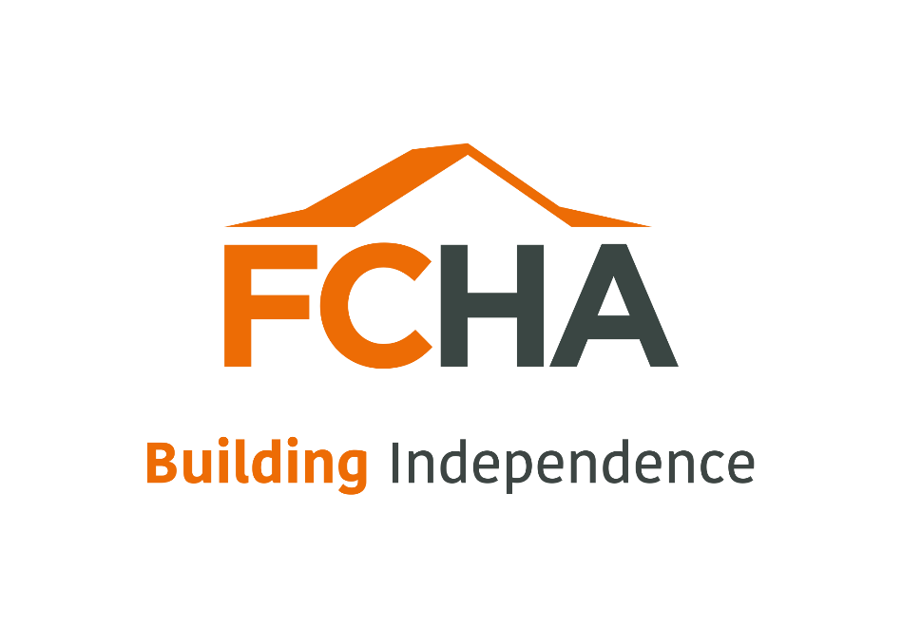

FIRST CHOICE HOUSING ASSOCIATION
Deeds not words
A pledge to end racial inequality in housing

Deeds not words action plan
Pledge | Action | Progress | Outcome
1.Mitigate the impact of Covid-19 on Black, Asian and other minority ethnic staff and communities | Apply the All Wales Covid-19 Risk Assessment Tool which recognises the increased risk of COVID-19 to BAME staff and act on findings (ensure concerns of Black, Asian, and other minority ethnic staff are treated seriously and addressed in a compassionate way, without the fear of being disadvantaged if work is realigned) | We have applied Risk Assessments in line with All wales tool and WG guidance and acted upon findings. We have allowed flexibility for staff to work remotely to safeguard their wellbeing and provided open frequent communication re our COVID planning. We have realigned work where necessary | Staff have fed-back positively throughout the pandemic on their satisfaction on how we have dealt with mitigating the impact of COVID19. We will continue to monitor this throughout 2021.
 | Commit to wellbeing/psychological and other support to Black, Asian, and other minority ethnic staff who might feel affected or vulnerable right now | Additional resources have been input into the wellbeing of staff including yoga and PT sessions and quizzes to allow time for social interaction. For those who are feeling more vulnerable we have provided assurance that they can continue to work remotely for the foreseeable future. We intend to recruit a Health & Wellbeing co-ordinator in 2021 who will link in alongside HR in ensuring the physical well-being of all staff, particularly those in underrepresented groups. | Staff from all groups have indicated they feel FCHA have/are continuing to support their psychological wellbeing.
 | Investigate reasons for overcrowding and worse housing conditions amongst some BAME groups. Start acting on findings. | FCHA has supported housing accommodation and therefore we do not have houses with overcrowding. However, we can consider our housing stock and its condition and relate this to the profiling data held for properties and act on findings. We will specifically review our general needs stock to identify an issues with housing standards. | Good quality housing for all tenants particularly in general needs properties where we can influence allocations to be of a more diverse nature with specific focus on reviewing the housing for BAME tenant groups.
2.Improve the ethnic diversity of board and staff at all levels | We will adopt the Rooney Rule in our board and staff recruitment | BAME candidates will be offered an interview providing they meet the essential job criteria-We will shortlist candidates before reviewing profiling data to avoid unconscious bias. All applications are separated from profiling data before shortlisting. However, in order not to fall foul of GDPR laws, you should ask for applicants consent to use information provided about their ethnicity in the recruitment process.  We will positively encourage the return of Equality returns with all job applications to enable us to identify BAME candidates. | More diverse workforce at staff and Board levels
 | Adopt the Rooney Rule in at job levels where you identify under representation | Where we identify a particular group is under-represented we will apply the Rooney Rule within a specific areas where we have the most under representation. We must caveat this by highlighting we are a small organisation and statistics can be misrepresentative so should be treated with caution. | Positive action to create a diverse workforce
 | Review annually and act on findings: ethnicities pay gap (where pay gap reporting is not possible due to small sample sizes – report BAME employee ratios at different levels) recruitment, promotion, and retention ethnicity data | We will develop our reporting structures to identify levels although due to our size this data may not be meaningful. We can compare and contrast retention for BAME employees in contrast to other staff groups. | Consistent review to ensure positive recruitment and retention of BAME groups.
 | Invest in recruitment channels to bring in more Black, Asian and Ethnic Minority applicants | Consider partnering with Race Council Cymru to help us open out and widen channels of recruitment and collaboration. | A number of positions have been advertised via Race Council Wales to try and attrat a more diverse membership
 | Train all staff and board in Unconscious Bias and raise awareness of white privilege | Training commenced in 2021 and will be continued for new staff and Board members bi-annually. | Awareness of unconscious bias at all levels throughout the organisation
 | Ensure ethnically diverse recruitment panels | Adopt the Rooney Rule where we will attempt to commit to having at least one woman and one under-represented minority in the slate of candidates considered for every open senior position, if the criteria for the  role is met. | Fair and equitable recruitment practices
 | Invest resources in positive action initiatives aimed at improving BAME representation at levels showing gaps. This can include leadership development programmes, mentoring/shadowing opportunities and internal talent pipeline initiatives | Invest resources in positive action initiatives aimed at improving BAME representation at levels showing gaps. This can include paid internships and apprenticeships, leadership development programmes, mentoring/ shadowing/coaching opportunities and internal talent pipeline initiatives. | Wider representation of BAME at all levels

3. Communicate and engage | Publicise your support for racial equality including voiced support for Black, Asian, and ethnic minority staff and tenants/communities, commitment to anti-racist practice and awareness of specific challenges facing your organisation or community | We will use our intranet, website & external social media channels to raise awareness and publicly support all campaigns to end racial injustice | Sector support to eliminate racial inequality in housing
 | Together with above - publish your commitment to take specific actions to tackle the challenges you identified. Report on progress annually. | Develop an anti-racist statement.  Report on progress against our action plan annually
 | Disaggregate ethnicity data in your tenant satisfaction surveys and other tenant surveys. Use other channels to learn about the experiences of BAME tenants. Act on findings. | Include questions within satisfaction surveys specifically in relation to experiences of underrepresented groups to both staff and tenants needs and wants and gather ideas on where we should be directing our efforts.  We will investigate our own performance in delivering services to determine whether data suggests unconscious bias in how we let and manage our homes | Learn from our own and others experiences of BAME groups and positively act upon findings
 | Build links with and support BAME community groups in the area and beyond, invest in building their capacity to support local communities and bring in community knowledge and challenge to the organisation | Partner with Race Council Cymru to enhance links with community leaders. | Improved links with partner organisations
 | In asylum dispersal areas, commit to donating or leasing housing to refugee housing initiatives (where these exist) | N/A-As we are a specialist RSL The LA have 100% nomination rights over FCHA supported properties and our general needs properties are specifically developed for veterans or people with a physical disability.  However, we can positively seek to work with partners in our general needs areas to seek tenants from BAME backgrounds provided they fall within the specialist housing category.

4. Develop an inclusive culture | Chief Executives, senior leaders and boards to take a proactive role in championing and monitoring progress on these pledges. | Board and Exec promote and champion the Deeds to Words Pledge with all staff  Board and Exec to undertake Race Equality questionnaire looking at diversity , representation and leadership of the Association  Tai Pawb presentation on Board Diversity to be made available via Decision Time  The Board and Executive Committee to receive regular updates on progress. We will ensure all Board reports consider the impact on equality and diversity and all policies and strategies consider an Equality Impact Assessment. | Full commitment by Board and Senior to deliver on the pledge

 | Chief Executives, senior leaders and boards to actively support and promote an inclusive culture where people are comfortable talking about race and can bring their whole self to work | Share reading materials , videos , podcasts and other resources available from Tai Pawb with staff and where appropriate tenants  Our responsibility as a business is to be clear about behaviours and be willing to challenge. The Chair, Chief Executive and Senior Leadership Team will all model behaviours by having open, honest discussions with their teams and by being visible to the business.  We will invest in education and learning  to open people’s minds and promote  thinking.  We will work with external organisations who have expert knowledge in this area to provide support and advice. | FCHA has an inclusive culture for staff and tenants to actively strive for a diverse community within the organisation  Assurance we act in accordance with FCHA Values.  Raised awareness within FCHA to avoid stereotyping, unconscious bias and common misconceptions.
 | Actively support and promote a culture where Black, Asian and Ethnic Minority staff and tenants are comfortable to voice concerns related to race and are believed when this happens | Rolling out e-learning to colleagues on unconscious bias.  Use experts in the field and guest speakers to give a further understanding of ethnic minority groups to reduce misconceptions and stereotyping.  Promote our Grievance, Whistleblowing and Complaints polices to ensure there is  an easy to understand route for colleagues and customers to follow should they  feel they have concerns regarding race issues.  Carry out a review of any tenant complaints to understand themes and trends.  Encourage an attitude of learning and discussion via team meetings, recommend books, films, music, TED talks etc. Share positive role models of Black, Asian and Ethnic  Minority people.  Support colleagues and customers to share their own views and experiences  should they wish to do so.
 | Invest in reverse mentoring schemes to share experiences and improve opportunities | Reverse mentoring can work in many different ways, whichever best suits the organisation. Investing doesn’t necessarily mean finance – it could mean time spent with colleagues, for e.g. younger BAME peers. We will discuss with partners such as Tai Pawb whether this is something they could help facilitate, especially as we do not have any staff from BAME. It could be that organisations can work across each other, or with younger BAME people who might be interested in working in the housing sector but don’t currently. Both sides have a huge opportunity to gain valuable insights into each other’s roles and experiences. | Shared experiences and good practice to support education , learning and awareness

