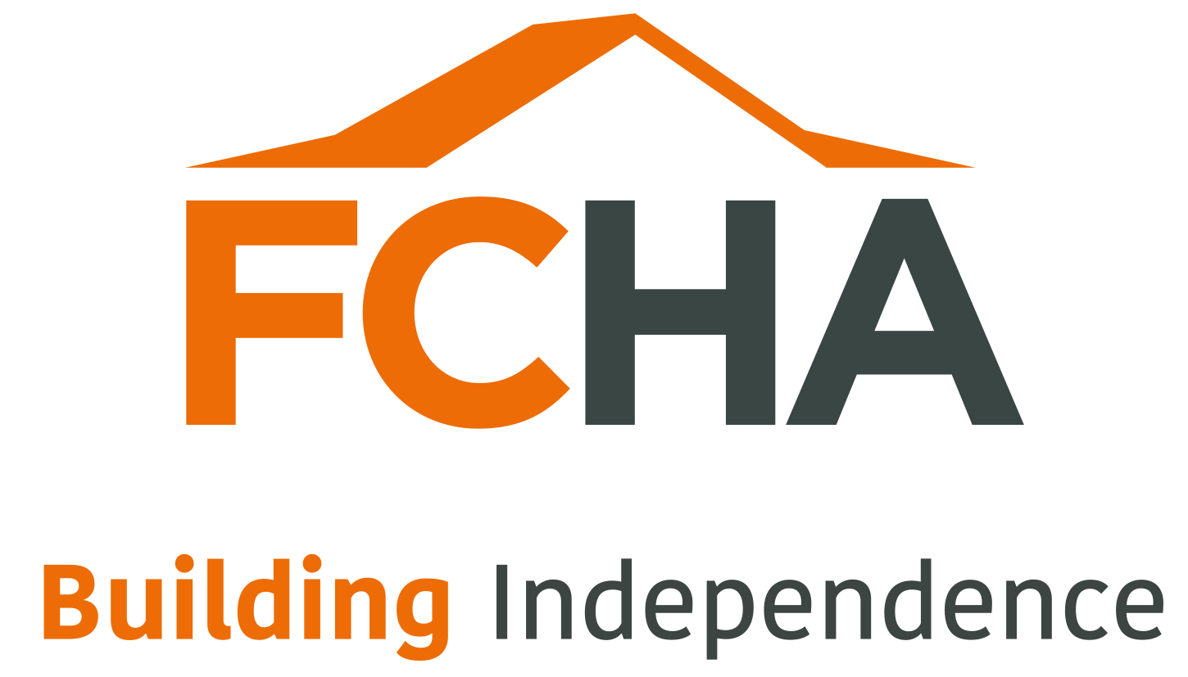

VERSION 5 | Date  17/3/25 | Approved by  DCSH

COMPLAINTS POLICY

November 2024

We want people to find it easy to complain and get things put right when the service they receive from First Choice is not good enough.

The Association’s policy is in accordance with the Model Complaints Policy
and Guidance for public services in Wales. The latter was developed by the Complaints Wales Group, chaired by the Public Services Ombudsman for Wales and has been endorsed by Welsh Ministers.

First Choice Housing Association is committed to dealing effectively with any concerns or complaints you may have about our services. We aim to clarify any issues about which you are not sure. If possible, we’ll put right any mistakes we may have made. We will provide any service you are entitled to that we have failed to deliver. If we did something wrong, we will apologise and where possible try to put things right. We aim to learn from our mistakes and use the information we gain to improve our services. First Choice are committed to encouraging equality, diversity, and inclusion among our workforce, and eliminating unlawful discrimination.

When to use this policy

When you express your concerns or complain to us, we will usually respond in the way we explain below. However, sometimes you may have a statutory right of appeal so, rather than investigate your concern, we will explain to you how you can appeal. Sometimes, you might be concerned about matters that are not decided by us, e.g. where the Welsh Government has not approved Physical Adaptations Grant funding. We will then advise you about how to make your concerns known.

This policy does not apply if the matter relates to a Freedom of Information or Data Protection issue. In this circumstance, you should contact the Director of Corporate Services & Housing, First Choice Housing Association, Unit 10 Village Way, Tongwynlais, Cardiff, CF15 7NE.

Have you asked us yet?

If you are approaching us for a service for the first time, (e.g. reporting a faulty electrical socket, requesting an appointment) then this policy doesn’t apply. You should first give us a chance to respond to your request. If you make a request for a service and then are not happy with our response, you will be able to make your concern known as we describe below.

Informal resolution ( we would class this as Stage 1 )

If possible, we believe it’s best to deal with things straight away. If you have a concern, raise it with the person you’re dealing with. They will try to resolve it for you there and then, but this will take no longer than 10 working days. If there are any lessons to learn from addressing your concern, then the member of staff will draw them to our attention. If the member of staff can’t help, they will explain why, and you can then ask for a formal investigation.

How to complain formally ( we would class this as Stage 2 )

You can express your concern in any of the ways below:

- You can ask for a copy of our concern and complaint form from the person with whom you are already in contact. Tell them that you want us to deal with your concern formally.
- You can get in touch with our central complaint contact point on
029 20703758 if you want to make your complaint over the phone.
- You can contact us via our website at www.fcha.org.uk/contactus.html
- You can e-mail us at customerservices@fcha.org.uk
- You can write a letter to us at the following address:
First Choice Housing Association, 10 Village Way, Tongwynlais, Cardiff, CF15 7NE

A copy of the concern and complaint form is at the back of this policy.

Copies of this policy and the complaint form are available in English, Welsh and any other language or format upon request e.g. audio, large print etc.

A concern may be defined as an expression of worry or doubt over an issue. A complaint may be defined as an expression of dissatisfaction however made about actions or lack of around maladministration and service failure.

Dealing with your complaint

The Operational Housing Managers are the Associations complaints officers. There is a manager responsible for both the South and North Wales regions depending on where you live.

- We will formally acknowledge your concern within 5 working days and let you know how we intend to deal with it.
- We will ask you to tell us how you would like us to communicate with you and establish whether you have any particular requirements – for example, if you have a disability.
- We will deal with your concern in an open and honest way. We will make sure that your dealings with us in the future do not suffer just because you have expressed a concern or made a complaint.

Normally, we will only be able to look at your concerns if you tell us about them within six months. This is because it’s better to look into your concerns while the issues are still fresh in everyone’s mind.

We may exceptionally be able to look at concerns which are brought to our attention later than this. However, you will have to give us strong reasons why you have not been able to bring it to our attention earlier and we will need to have sufficient information about the issue to allow us to consider it properly. (In any event, regardless of the circumstances, we will not consider any concerns about matters that took place more than three years ago.).

If you are expressing a concern on behalf of somebody else, we will need their agreement to you acting on their behalf.

What if there is more than one organisation involved?

If your complaint covers more than one organisation, such as the Local Authority Social Services Department or a support provider organisation, we will usually work with them to decide who should take a lead in dealing with your concerns. You will then be given the name of the person responsible for communicating with you while we consider your complaint.

If the complaint is about an organisation working on our behalf such as contractors or anyone whom First Choice has asked to visit your property you may wish to raise the matter informally with them first. However, if you want to express your concern or complaint formally, we will look into this ourselves and respond to you.

Investigation

We will tell you who we have asked to look into your concern or complaint. If your concern is straightforward, we’ll usually ask somebody from the service to look into it and get back to you. If it is more serious, we may use someone from elsewhere in the Housing Association or we may appoint an independent investigator.

We will set out to you our understanding of your concerns and ask you to confirm that we’ve got it right. We’ll also ask you to tell us what outcome you’re hoping for. The person looking at your complaint will usually need to see the files we hold relevant to your complaint. If you don’t want this to happen, it’s important that you tell us.

If there is a simple solution to your problem, we may ask you if you are happy to accept this. For example, (where) you have asked for a service and we see straight away that you should have received it, we will offer to provide the service rather than investigate and produce a report.

We will aim to resolve concerns as quickly as possible and expect to deal with the vast majority within 20 working days. If your complaint is more complex, we will:

- Let you know within this time why we think it may take longer to investigate.
- Tell you how long we expect it to take.
- Let you know where we have reached with the investigation, and
- Give you regular updates, including telling you whether any developments might change our original estimate.

The person who is investigating your concerns will aim first to establish the facts. The extent of this investigation will depend on how complex and how serious the issues you have raised are. In complex cases, we will draw up an investigation plan.

In some instances, we may ask to meet you to discuss your concerns. Occasionally, we might suggest mediation or another method to try to resolve disputes.

We’ll look at relevant evidence. This could include files, notes of conversations, letters, e-mails or whatever may be relevant to your particular concern. If necessary, we’ll talk to the staff or others involved and look at our policies and any legal entitlement and guidance.

Outcome

If we formally investigate your complaint, we will let you know what we have found in keeping with your preferred form of communication. We’ll explain how and why we came to our conclusions, what happened and why, impact on the complainant, any actions to change a systemic issue so that it doesn’t happen again and other things we will do to put it right. We will apologise and redress if we got things wrong.

Putting Things Right

If we did not provide a service, you should have had, we will aim to provide it now if that is possible. If we did not do something well, we will aim to put it right. If you have lost out as a result of a mistake on our part, we will try to put you back in the position you would have been in if we had got it right.

If you had to pay for a service yourself, when you should have had one from FCHA, or if you were entitled to funding you did not receive, we will usually try to refund the cost.

Ombudsman

If we do not succeed in resolving your complaint and your property is in Wales, you have the right to complain to the Public Services Ombudsman for Wales. The Ombudsman is independent of all government bodies and can look into your complaint if you believe that you personally, or the person on whose behalf you are complaining:

- have been treated unfairly or received a bad service through some failure on the part of the organisation providing it; or
- have been disadvantaged personally by a service failure or have been treated unfairly.

The Ombudsman expects you to bring your concerns to our attention first and to give us a chance to put things right.
“If you are unhappy with this response to your complaint, you have the right to contact the Public Service Ombudsman for Wales. The Ombudsman can accept complaints through her website using the online complaint form, in writing, or over the phone. The Ombudsman’s contact details are:

Phone: 0300 790 0203
Online complaint form: https://complaints.ombudsman.wales/en/pre-complaint
Address: Public Services Ombudsman for Wales, 1 Ffordd yr Hen Gae, Pencoed, CF35 5LJ
Website: www.ombudsman.wales”
There are also other organisations that consider complaints. For example, the Welsh Language Commissioners Office deals with complaints about services in Welsh. We can advise you about such organisations.

Learning lessons

We take your concerns and complaints seriously and try to learn from any mistakes we’ve made. Our senior management team considers a summary of all complaints quarterly as well as details of any serious complaints. Our Board of Management also receive reports on the number, type and outcomes of complaints as well as remedial action on a quarterly basis. When closing a complaint, we will identify the root cause to enable lessons from the complaint and investigation to be learnt. This will be including a follow up of improvements to be made.

Where there is a need for change, we will develop an action plan setting out what we will do, who will do it and when we plan to do it by. We will let you know when changes we have promised have been made.

What if I need help

Our staff will aim to help you make your concerns known to us. If you need extra assistance, we will try to put you in touch with someone who can help. You may also wish to contact a family member, your support provider (if you have one) or an advocacy service (who may be able) to assist you.

You can also use this concerns and complaints policy if you are someone under the age of 18. If you need help, you can speak to someone on the Meic Helpline (phone 080880 23456, www.meiccymru.org) or contact the Children’s Commissioner for Wales. Contact details are:

01792 765600 (South Wales) 01492 523333 (North Wales)
post@childcomwales.org.uk
www.childcom.org.uk

What we expect from you

In times of trouble or distress, some people may act out of character. There may have been upsetting or distressing circumstances leading up to a concern or a complaint. We do not view behaviour as unacceptable just because someone is forceful or determined.

We believe that all complainants have the right to be heard, understood and respected. However, we also consider that our staff have the same rights. We therefore expect you to be polite and courteous in your dealings with us. We will not tolerate aggressive or abusive behaviour, unreasonable demands or unreasonable persistence. We have a separate policy to manage situations where we find that someone’s actions (are) unacceptable.

Post Complaint

Retain the documents
Implement any systemic changes
Implement any learning with staff involved
Wider lessons learnt /continuous improvement considerations/staff training
Recording and monitoring of complaints

Complaint form

A: Your details

Surname | Forename(s): | Title: Mr/Mrs/Miss/Ms/if other please state:

Address and postcode:

Your e-mail address:

Daytime contact phone number

Mobile number:

Please state by which of the above methods you would prefer us to contact you:

_______________________________________________________________

Your requirements: if our usual way of dealing with complaints makes it difficult for you to use our service, for example if English or Welsh is not your first language or you need to engage with us in a particular way, please tell us so that we can discuss how we might help you:

_______________________________________________________________

The person who experienced the problem should normally fill in this form. If you are filling this in on behalf of someone else, please fill in section B. Please note that before taking forward the complaint we will need to satisfy ourselves that you have the authority to act on behalf of the person concerned.

B: Making a complaint on behalf of someone else: Their details

Their name in full:

Address and postcode:

What is your relationship to them?

Why are you making a complaint on their behalf?

C: About your concern/complaint (Please continue your answers to the following questions on a separate sheet(s) if necessary)

C.1 Name of the department/section/service you are complaining about? e.g. Maintenance, Housing Management, Development:

_______________________________________________________________

C.2 What do you think they did wrong, or failed to do?

_______________________________________________________________

_______________________________________________________________

C.3 Describe how you personally have suffered or have been affected.

_______________________________________________________________

_______________________________________________________________

_______________________________________________________________

C.4 What do you think should be done to put things right?

_______________________________________________________________

_______________________________________________________________

C.5 When did you first become aware of the problem?

_______________________________________________________________

C.6 Have you already put your concern to the frontline staff responsible for delivering the service? If so, please give brief details of how and when you did so.

_______________________________________________________________

_____________________________________________________________

C.7 If it is more than 6 months since you became first aware of the problem, please give the reason why you have not complained before now.

_______________________________________________________________

_______________________________________________________________

_______________________________________________________________

_______________________________________________________________

If you have any documents to support your concern/complaint, please attach them with this form.

Signature: _________________________________ Date: _______________

When you have completed this form, please send it to:

Complaints Officer
First Choice Housing Association, 10 Village Way, Tongwynlais, Cardiff CF15 7NE

E-mail: customerservices@fcha.org.uk

Telephone: (029)2070 3758

A Welsh Version is available upon request

